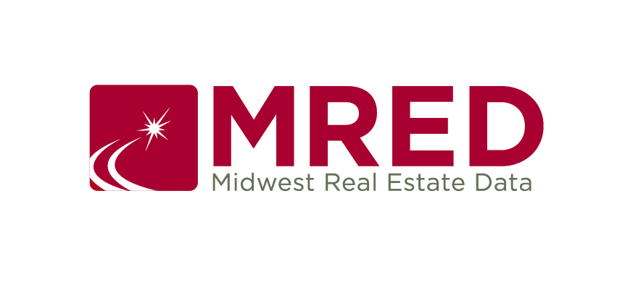

IDX Program

(Internet Data eXchange)

What is IDX?
IDX is a program allowing MLS Participants to give each participating company in the program permission to display each other’s listings on brokers/agents website(s). For more details on MRED’s IDX program, see MRED rules and regulations section 32.

IDX Logos and Usage Guidelines
- Licensed IDX MRED participants may use the IDX icon/logo provided below.
- MREDLLC is the owner of the MRED IDX logos.
- Do not modify the MRED IDX logos without permission.

96 x 29 pixels

35 x 35 pixels

To download the image, right click on the image, choose “Save As…” or “Save Image As…” and save the image to your computer. Need help? Send an email to IDX@mredllc.com.

